A Link Between Worlds: Household Income, Stress, and Health

Jessica I. Trochez  
Psychology of Social Behavior   
April 16, 2017

Abstract

A multitude of scientific literature have assessed and emphasized the correlation between people’s stress and welfare. These preexisting studies observed how different determinants of socioeconomic status such as one’s level of education, race, and ethnicity can strongly influence their physiological as well as psychological distress. With the help of Google Forms, the research group in this particular study utilized a survey research design, in which 163 participants from Santa Fe College and social media outlets participated in, to evaluate the association between one’s household income, dietary, and mental health. The intention of the study was to verify earlier debates regarding the positive relation between income distribution and health indicators. As a result, the data was divided into clusters specifically into the three main socioeconomic classes: low, middle, and upper. The research was able to investigate the degree of the impact certain aspects would induce on each class; it became numerically possible to conclude whether one or the other scored higher on a measured indicator like a six-point stress scale in which participants were asked to rate stress levels. In retrospect, the results demonstrated how the lower class is often at a disadvantage whereas the middle fluctuates and the upper class report an overall healthier lifestyle. This is due to combinations of social, economic, and medical determinants of health which were carefully assessed per responder.

A Link Between Worlds: Household Income, Stress, and Health

The research group executed a survey research study in which a sample of respondents from a population were administered a questionnaire. For data collection and analysis, the researchers referred to their unique Google Forms survey, which was distributed to social media outlet users as well as several Santa Fe College students enrolled in a Psychology of Social Behavior class taught by psychology professor Ryan Keith. Overall, the sample size was 163 participants.  
 The study specifically examined the correlation between different levels of household income and patterns of health as well as stress. Prior to critique of the data collected, the researchers formulated three hypotheses: low-income households eat lower quality foods resulting in bad health; lower-income households are affected physically and mentally while higher-income households are affected emotionally and mentally; lack of opportunities in community settings leads to lack of employment, which causes more stress. Because stress is such a complex issue, the questionnaire attempted to measure several quantitative factors strongly associated with mental and physiological health.   
 The authors of the study also suggested how exposure of different environments as a result of one’s household income and current socioeconomic status majorly influenced people’s overall mental and physical well-being and their ability to maintain a healthy lifestyle. Additionally, they highlighted how participants that frequently engage in healthy behaviors (e.g. how many times the individual has take-out, whether they smoke) and report an overall healthier lifestyle belonged to high-income households. These conclusions were derived from existing literature which demonstrated how dispositional factors (e.g. how a person reacts to stress) are not quite exactly why some people engage in healthier lifestyles than others. In fact, those who report lower levels of stress and pathology tend to belong to high-income households not only because they are exposed to high-quality resources, but also because they can actually afford them (Hernández, Phillips, & Siegel, 2016). In other words, situational factors, such as access to healthcare and job opportunities, are significantly related to the overall satisfaction of one’s life (Conger R, Conger K., & Martin, 2011) and what people have access to is associated with how people perceive and cope with stress.

Method

To collect data, the researchers executed a survey research study in which a sample of respondents from a population were administered a questionnaire with a wide range of questions regarding their socioeconomic status. The purpose of the questionnaire was to describe, explore and explain how several stressors involved in different levels of household income affect a person’s welfare and lifestyle choices.

The researchers’ first step was determining where to gather test subjects from. With a total of 171 participants, 81 social psychology college students enrolled in psychology professor Ryan Keith’s class at Santa Fe College and 90 social media outlet users provided their feedback. However, it was taken into account that these two clusters completed the survey with different intentions—whereas the college students were promised extra credit for their social psychology class, the social media outlet users simply provided their feedback with no expectation of a reward or benefit. Despite this, anonymity was preserved, as the participants were not followed up with their questionnaires. To eliminate outliers which risk skewing the data, those who trifled with the survey by answering with obscene or irrelevant answers were removed from the sample size. Additionally, those did not answer all mandatory questions were removed, which still left a large sample size of 163 participants for the study.

The materials utilized to conduct the study was a Google Forms survey created by the researchers which attempted to measure and quantify certain socioeconomic conditions and possible stressors of each participant. 21 questions divided by 3 significant dimensions of the study—demographics, socioeconomic status, and health—were considered. Variables of interest included household income or the amount of money the participants’ household earns which ranged from low class, (less than $50,000), middle class ($50,000 to $100,000), and upper class ($100,000); family dynamics which asked for the location of the household, number of children living in the household if any, contributors of income, and whether or not the participant identified as financially independent or dependent; level of education was taken into consideration as community college classes are diverse especially in terms of the expected age range. Additionally, because social media outlet users were involved, it was vital to also consider that not all participants are enrolled in college or above. Occupation(s) were examined and whether or not their job is physically/emotionally demanding; eating habits were also asked as the amount of times a week people have takeout, eat out, or eat pre-made meals may contribute to poor health and diet. After completing their survey, participants that were expecting extra credit from taking the survey provided a unique ID which was then saved after they submitted the survey. The same participants then uploaded their ID as an assignment or text entry on their Psychology of Social Behavior class’s Canvas page. On the contrary, participants from social media outlets had the option to write in an ID.

Results

Prior to examining their study’s variables regarding socioeconomic status, stress, and health that are associated with stress, the researchers predicted that people who identify as belonging to a high-income household would report less stress and healthier stress coping mechanisms and dietary habits as compared to middle and low-income households. To assess this, the research group divided their data into three clusters. According to which household participants identified as—either low, middle, or upper class—their answers were then classified under that cluster.   
 Overall, 87 people (53.4%) belonged to a low-income household. 65 people (39.9%) identified as living in a middle-income household, and 11 people (6.7%) reported they belonged to a high-income household (Appendix A & B). This equals to a sample size of 163 participants, 81 of which were SF students and 82 people from social media. The participants were then asked questions regarding their health. First, they were asked how many times a week they felt stressed. The results showed that 80.3% of individuals belonging to low-income households tend to report the most weekly stress, as they answered a frequency of 4 or more. About 66.1% of participants belonging to middle-income households reported feeling stressed 4 or more times a week and about 72.7% of participants in high-income households reported a frequency of 4 or more. Altogether, the lower class reported experiencing the most amount of stress as compared to the middle and upper class (Appendix C). The researchers also asked participants, with the aid of a stress scale of 1 to 5, to rate their level of stress or anxiety when thinking about their socioeconomic status. From 5 to 1 (refer to Appendix D), it is evident that the lower class tends to report high levels of anxiety when reminded of their socioeconomic status. When rounded to the nearest whole number, lower class reports on average a stress level of 4, middle class reports an average of 3, and upper class reports an average of 2.   
 Further into the survey, the participants were then asked to check off which stress coping mechanisms they do, which was then used to analyze which behaviors are most common within each class. Based on the research group’s results (refer to Appendix E), technology/entertainment use (low: 70, middle: 45, upper: 9) and binge eating (low: 33, middle: 14, and upper: 4) is very high among all 3 classes whereas alcohol and/or smoking (low: 10, middle: 7, upper: 3) and therapy/counseling (low: 5, middle: 2, and upper: 1) is relatively the lowest. Overall, low-income households frequently engage in unhealthy behaviors as compared to the middle and high-income households.  
 Regarding their diet, participants were asked how many times a week they have takeout, eat out, or eat pre-made meal like Lunchables or ramen. The results (Appendix F) demonstrated relatively the same amount for each class when looking at each cluster and the sample size.

49 out of 86 from the low class reported 1 to 3 times a week, followed by 32 out of 66 from the middle class, and 5 out of 11 from the upper class. At the end of the survey, participants were asked whether or not they eat foods high in fats, calories, artificial colors/flavoring and preservatives. They had the choice to select Yes, No, or I Don’t Know. All three clusters scored relatively high under “Yes,” a moderate amount declared “No,” and a handful in each class were unsure of their food intake (Appendix G), but based on the sample size of this particular study, low-income households generally reported eating more fatty foods or foods with artificial flavorings and preservatives. 66.7% of participants in low-income household said “Yes” whereas 53.9% in middle-income scored “Yes,” and 63.6% in high-income households reported “Yes.” Overall, the findings in this study demonstrate that health is positively correlated with an individual's socioeconomic status—the higher the income, the healthier the lifestyle.

Discussion

The research group of this particular study intended to contribute to previous studies that support the notion of a strong correlation existing between one’s income and the quality of their lifestyle. To do so, variables regarding socioeconomic status, stress, and health that are consistently associated with stress were assessed among Santa Fe College Social Psychology students and social media users. Participants were asked to describe these different factors such as their household income and structure, level of education, occupation(s), and eating habits through anonymous responses to questions in a survey. All answers were then classified according to their household income.   
 Although the results were divided into three clusters, the research group took into consideration that there would be a large amount of variance when comparing each of them to each other. For example, because the sample size of those who identified as belonging to a high-income household was much less than low and middle class, percentages were numerically higher than the middle class despite the graphs demonstrating lower levels. But, when viewing data exclusively under the upper-class, the results are statistically significant. Overall, the researchers’ results demonstrated a positive correlation between a person’s income and quality of life; those who experienced the lowest stress levels and engaged in healthier or beneficial dietary and methods of stress coping belonged to the upper class. In other words, the higher a person’s income, the higher the quality of their lifestyle and satisfaction with their life. This is possibly due to the ability to actually afford the highest-quality of resources.  
 A strength of the study was inclusivity, as they were able to analyze several socioeconomic factors critical to people’s health. As a result, these studies can further contribute to others. In turn, the data can also push schools, health providers, and political representatives into recognizing that there is a need to preserve or establish fundamental basic human rights (e.g. free healthcare) that are evidently lacking in regions with low and middle-income households. Additionally, the study included the middle class, as there are claims that the middle class is slowly dissipating.  
 Despite the study’s several strengths, it also had its limitations. Foremost, the sample size for each class should be about the same, as each cluster intends to represent a realistic population. Also, instead of using only a survey, a longitudinal, cluster cohort method should be utilized if repeated again. This would allow monitoring of an individual level of change for a long period of time, meaning that variation can be observed from a broad spectrum rather than a specific population only once. Additionally, the researchers measured much more categorical variables than quantitative findings to support their hypotheses. To conclude, future repetitions of this study should further investigate the underlying causes for people’s stress in each class. For example, an abundance of evidence shows how members of racial minority groups are far more likely to have lower-incomes (Keister, 2004) and tend to experience racial/ethnic inequality regarding wealth ownership; this has proven to be one of the most persistent forms of stratification in the United States

References

Conger K., Conger R., & Martin M. (2011). Socioeconomic status, family processes, and  
 individual development. *Journal of Marriage and Family*, 72(3), 685–704.

Hernández D., Phillips D., & Siegel L. E. (2016). Exploring the housing and household energy  
 pathways to stress: a mixed methods study. *International Journal of  
 Environmental Research and Public Health*, 13(9), 916-929.

Keister, L. (2004). Race, family structure, and wealth: the effect of childhood family on

adult asset ownership. *Sociological Perspectives*, 47(2), 161–187.

Sewell W., & Shah V. (1967). Socioeconomic status, intelligence, and the attainment of higher  
 education. *Sociology of Education*, 40(1), 1-23.

Appendix A

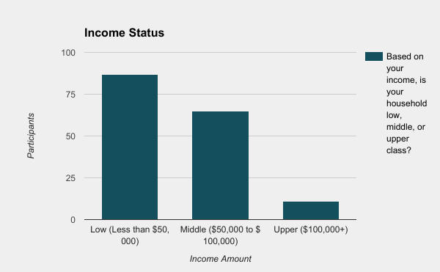

Appendix B

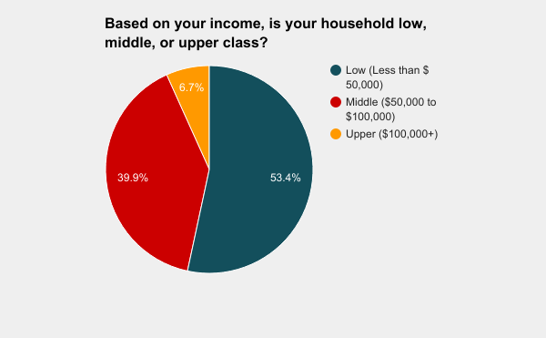

Appendix C

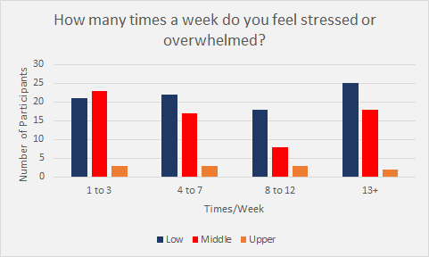

Appendix D

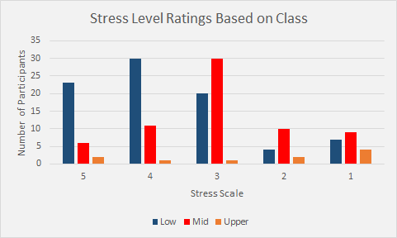

Appendix E

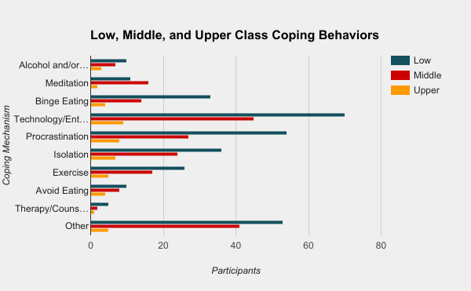

Appendix F

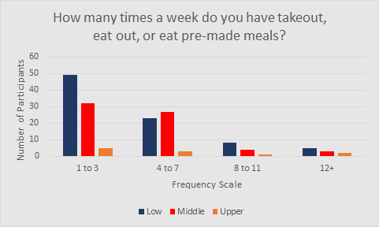

Appendix G

